For this post, I bring you two whole apps. I’ve updated Q-Tools and Watch Folder for Vault 2013. Technically the 2012 versions can still work with Vault 2013 server, but there were a few optimizations I wanted to do using the new API features.

Q-Tools 2013
For Q-Tools, the feature set is the same as before, but I make use of the new Job.IsOnSite parameter to determine if a job needs to be rerouted or not.
Here is the full feature list:
- Logging - Issues are logged to a text file.
- Stale Job Detection - Jobs on the queue too long can be considered an issue.
- Email Reports - Issues can be emailed to one or more recipients.
- Queue Cleanup - Jobs with issues can be automatically removed from the queue.
- Queue Forwarding - In multi-site and multi-workgroup environments, jobs can get routed to a single site.
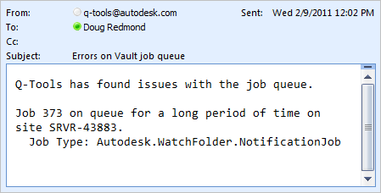
Requirements:
- Vault Workgroup/Collaboration/Professional 2013
- Job Server feature enabled
Click here to download the application
Click here to download the source code
To setup:
- Designate a computer on the network that the Q-Tools service should run on. Only 1 Q-Tools can be running for a given Vault deployment.
- Run the installer.
- Go to the installation folder and update the settings.xml. The XML comments will explain this step.
- Run the Q-Tools service.
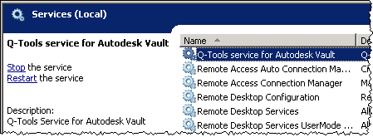
As with all the samples on this site, the legal disclaimer applies.

Watch Folder 2013
Although the feature set is the same, the setup is much easier. No longer do you have to configure Windows tasks to add notification jobs to the queue. Using the new features on IJobHander, the jobs are added from JobProcessor plug in. Right before JobProcessor goes idle, Watch Folder puts a new notification job on the queue. That way new files are checked every time JobProcessor cycles.
In case you aren't familiar with it, Watch Folder is an app that allows you to "watch" a set of Vault folders so that you receive email notifications when files get added or updated in those folders.
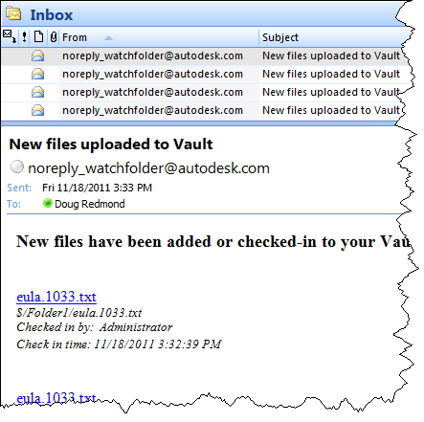
Requirements:
- Vault Workgroup/Collaboration/Professional 2013
- Job Server enabled
- An SMTP server somewhere on the network
NOTE: This isn't something you can just download and run. The Vault administrator needs to set up some server components before this feature can be used.
Click here to download the application
Click here to download the source code
To use
For Vault users, download the application and run the installer. Just make sure that the administrator has set up the Vault environment first. Next, start up Vault Explorer and right-click on a folder that you want to watch. Select the Watch Folder command and decide how frequently you want notifications.
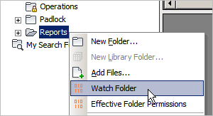
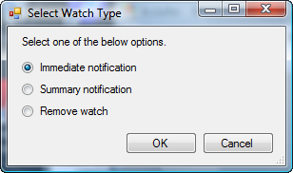
For Vault administrators, download the application and run the installer. Next follow the instructions in the readme file in the install folder (%ProgramData%\Autodesk\Vault 2013\Extensions\WatchFolder).
Notes:
- A watch on a folder will automatically apply to any sub-folders.
- Removing a watch will also remove watches on sub-folders.
- You can't have an immediate watch and a summary watch on the same folder. Setting a folder to one type overwrites the existing setting.
- You need to be at least Document Editor (level 1) in order to set up a watch on a folder.
- You need to have a valid email address in your Vault user settings.
- The contents of the email can be customized by the Vault administrator. See readme file.
Migrating from Watch Folder 2012:
- WatchSettings.xml now needs a Vault username and password. Everything else is the same, so you can just add <Vault_Username> and <Vault_Password> tags to your existing config file. The Vault user must be able to add and delete jobs from the queue.
- All the other settings files from R1 can still be used, just copy over WatchCollection.xml and WatchEmailBody over to the install folder.
As with all the samples on this site, the legal disclaimer applies.

